GRADE 7 ACCELERATED · UNIT 2 · ASSESSMENT  Real Numbers and Roots  34 points | Name_________________________  Date__________________________  Period________________________  Score __________ / 34

Show your work. Circle your final answer.
1. Locating Real Numbers on a Number Line | 7 points

1. A number line is shown. Give the letter of the point that is closest to each value. | 3 points

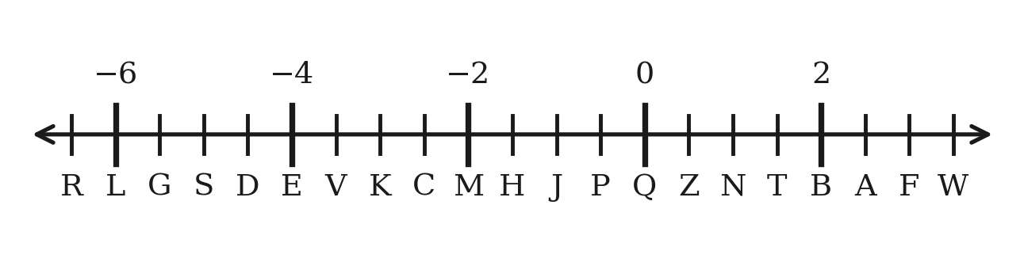
a. 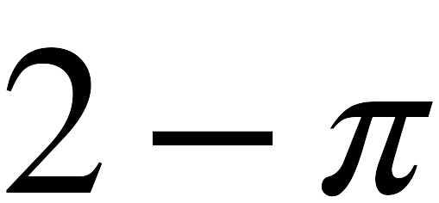

b. 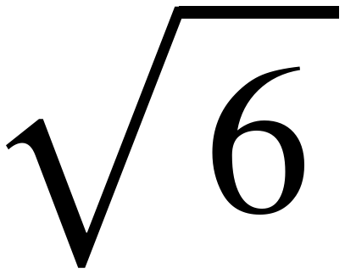

c. 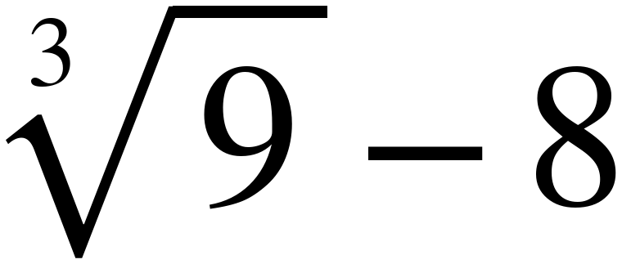

2. For each value, write the two consecutive integers it lies between, the integer it is closer to, and the comparison you used. | 4 points

Value | Lies between | Closer to | How you know
a. 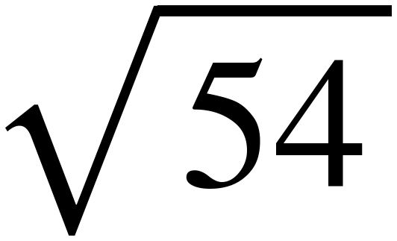
b. 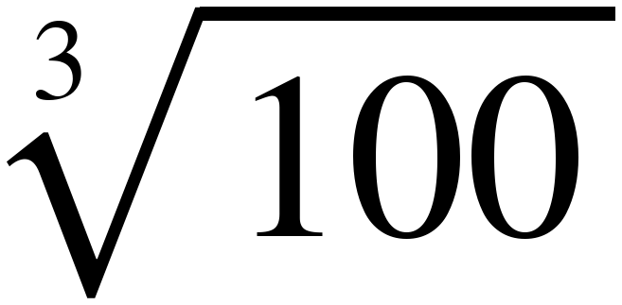
c. 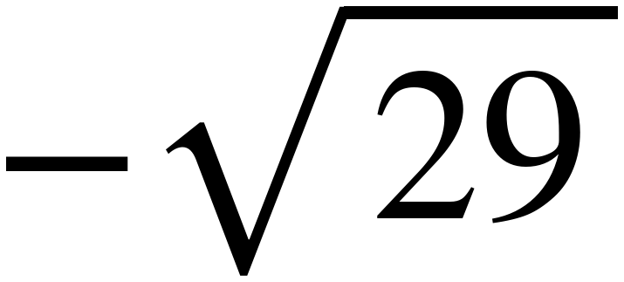
d. 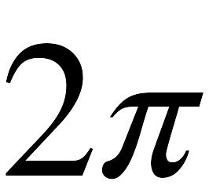

2. Roots and the Equations They Solve | 11 points

3. Write every value that makes each statement true. | 4 points

a. 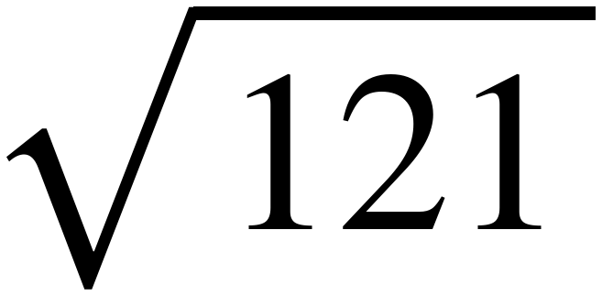 = ________________________

b. If 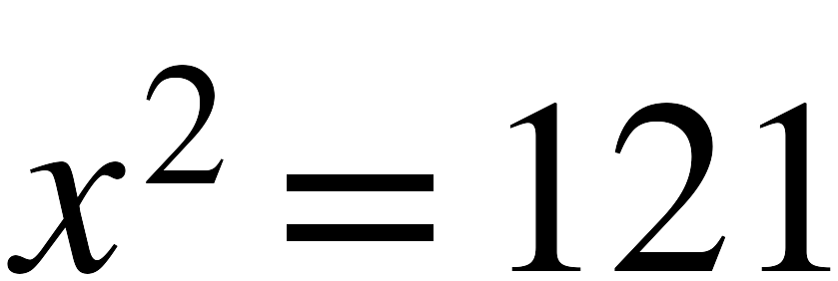, then x = ________________________

c. 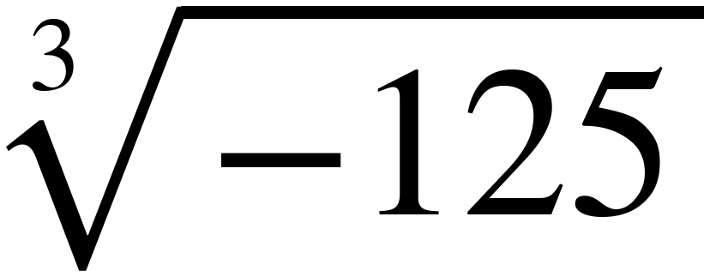 = ________________________

d. If 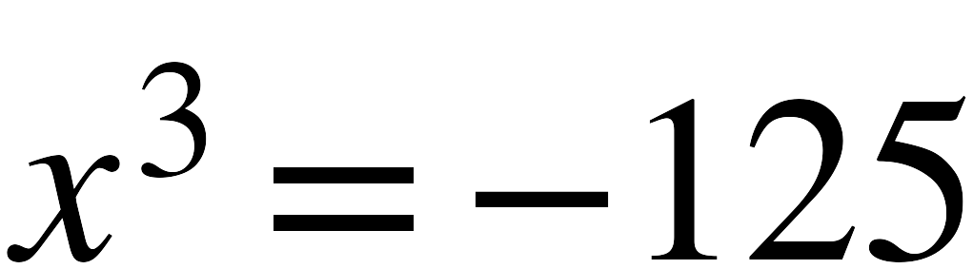, then x = ________________________

4. For each equation, select all of the solutions. | 4 points

 | 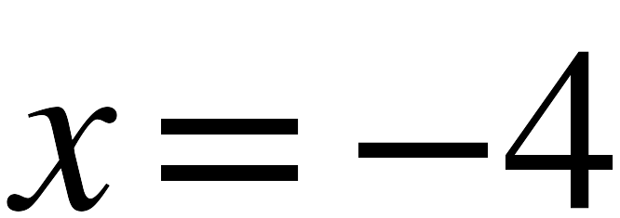 | 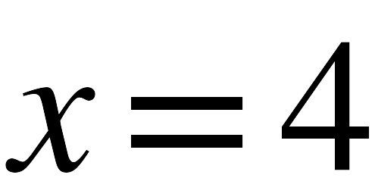 | 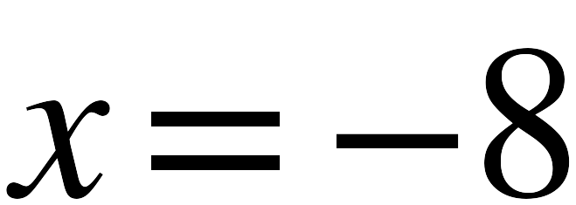 | 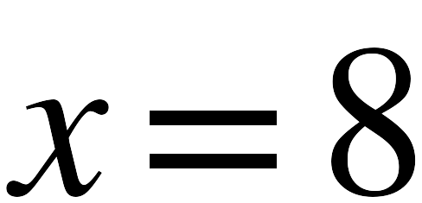 | no real solutions
a. 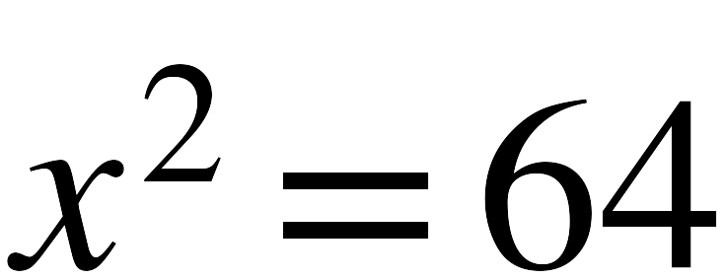 | 
b. 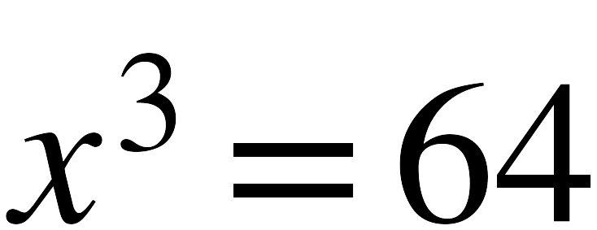
c. 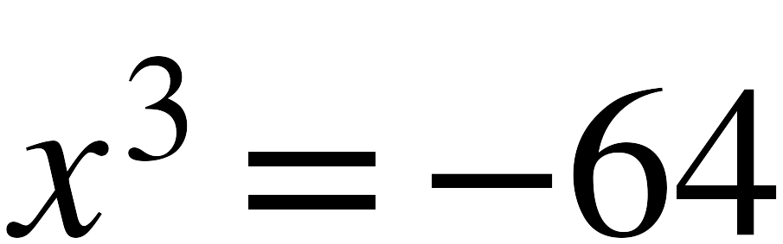
d. 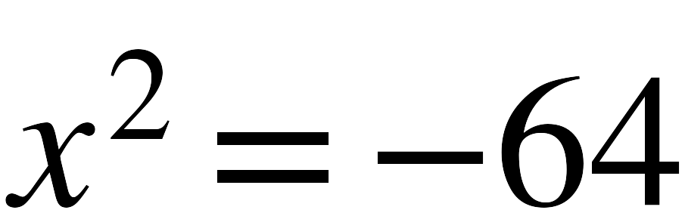

5. Complete each statement. | 3 points

a. When x is any real number other than 0 and it is multiplied by itself, the result will

 |  always | sometimes | never

be a
 | positive | negative

value.
b. Therefore, equations in the form 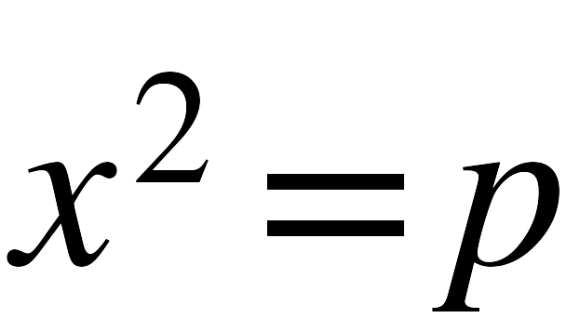 , where p is a whole number greater than 0, will have

 | only one solution. | two solutions. | three solutions.

c. How many solutions does 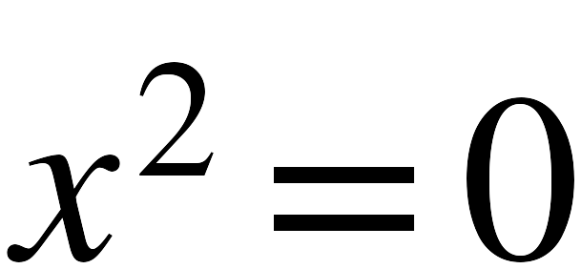 have?

3. Ordering and Comparing Real Numbers | 10 points

6. List the numbers below from least to greatest. | 1 point

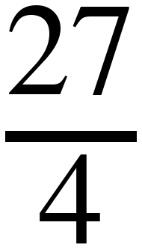 , 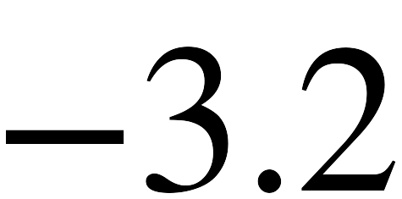 , 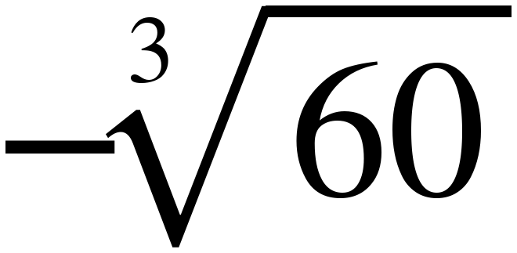 , 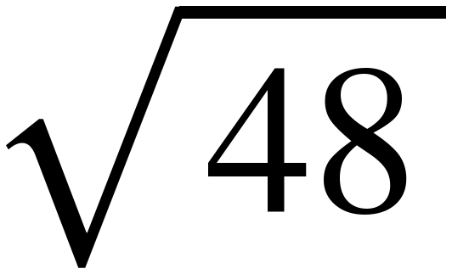 , 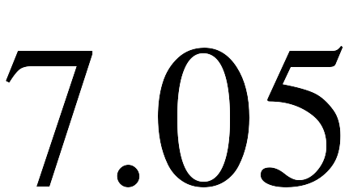

7. Compare each pair. Select <, > or =. | 5 points

a. | 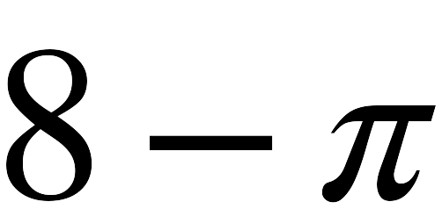 | < > = | 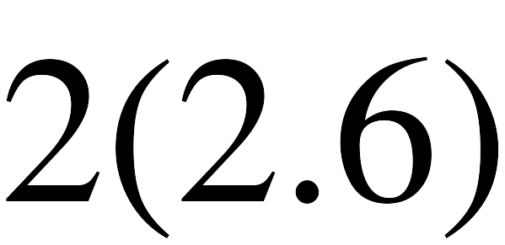
b. | 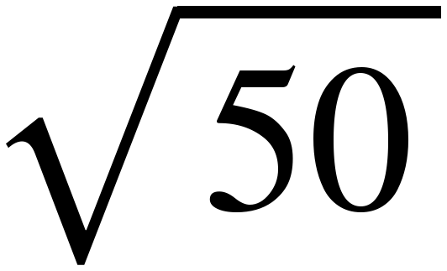 | < > = | 
c. | 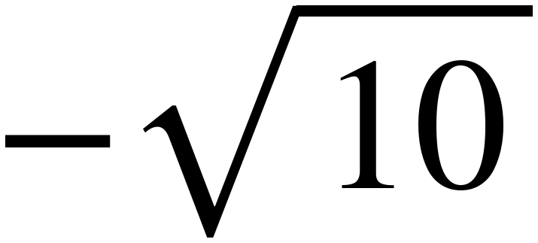 | < > = | 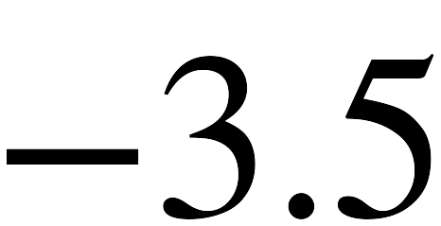
d. | 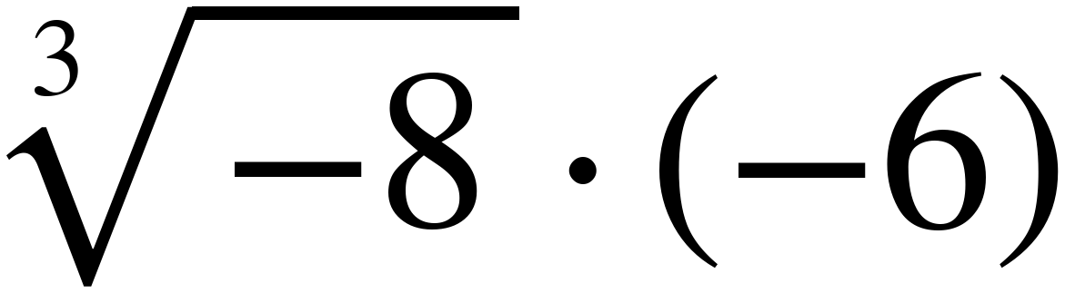 | < > = | 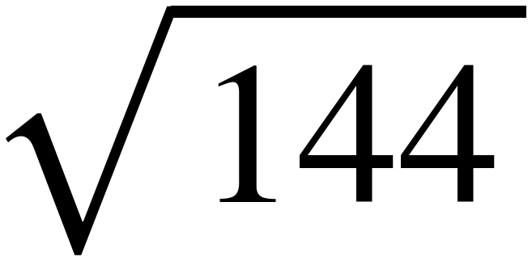
e. | 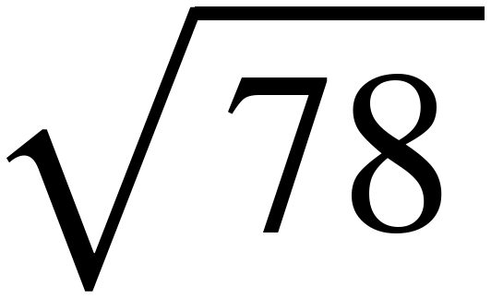 | < > = | 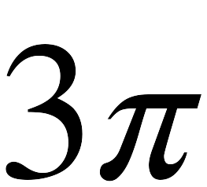

8. Plot and label each value on the number line. | 4 points

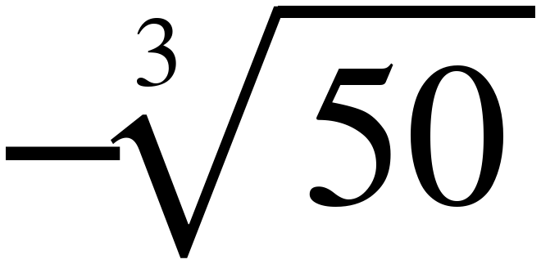 , 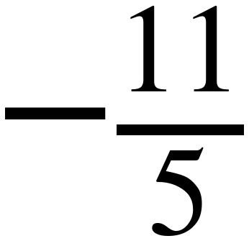 , 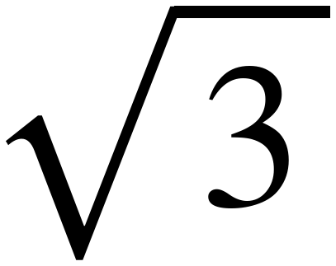 , 
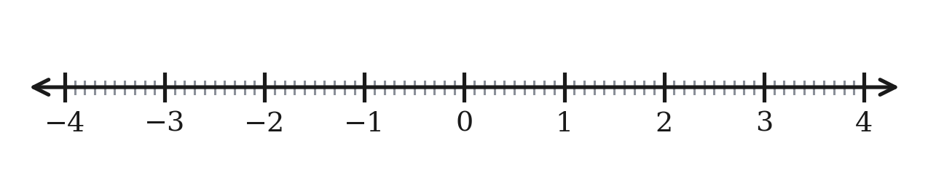

4. Rational or Irrational | 6 points

9. Write each number in the correct column of the table. | 6 points

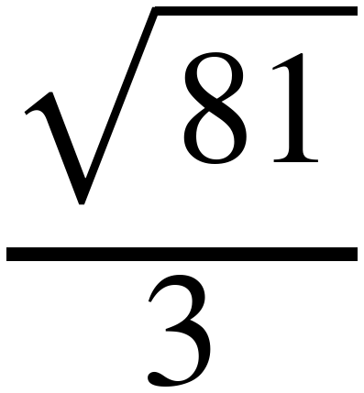 , 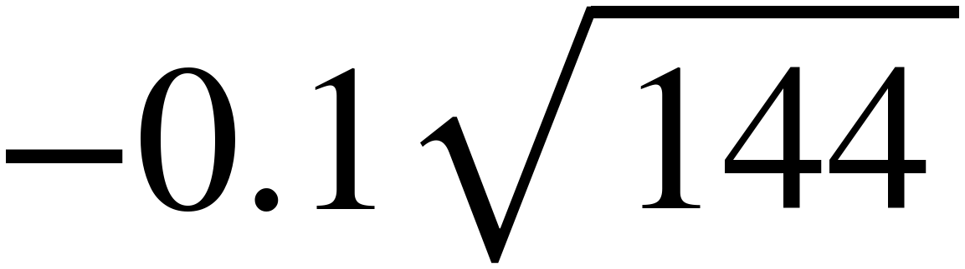 ,  , 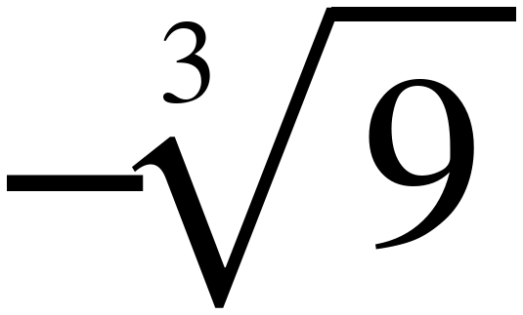 , 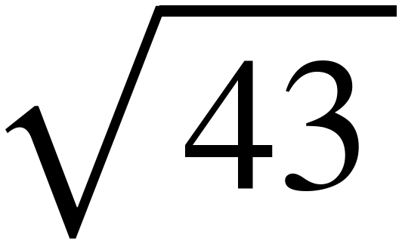 , 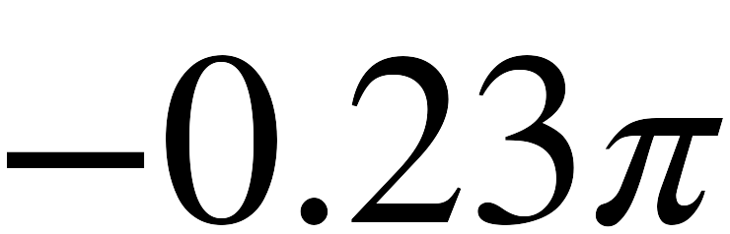
Rational Number | Irrational Number

